Linear Systems & Augmented Matrices

Solutions of Linear Equations
Givenreal numbers, we say thatis a solution to a linear equationif the equation is satisfied when we substitute the values into the equation accordingly.

In other words, if,is a solution to.

In even simpler words, for example given a linear equation, such aswhat are the numbersthat I can plug into the equation such that it is true?

Or if given, what are the numbersthat I can plug into the equation such that it is true?

Given the equation,is one of the infinitely many possible solutions to the equation, because. Similarly,is another possible solution since.

Geometrical Representation of Solutions of Linear Equations
The solutions of an equation can be visualised geometrically. For example, given the formula, we can represent all the solutions as a line.

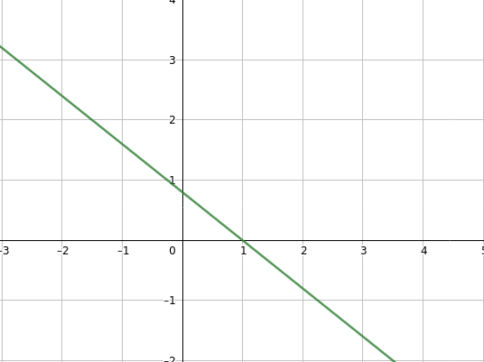
Similarly, for the general equation, we can represent it’s solutions as a plane.

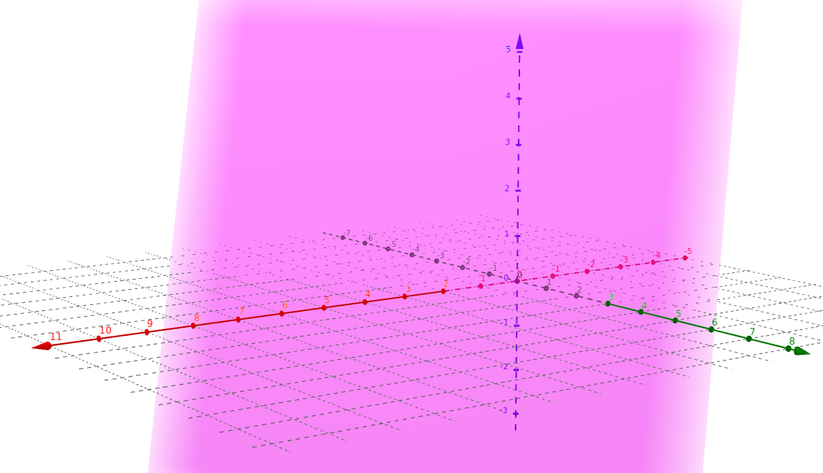
You might recogniseas a plane equation and that is no coincidence. Any point in that plane will satisfy the equation. Let’s call this plane. This means that the normal of our plane isand.

General Solutions of Linear Equations
Consider the linear equationwhich has infinitely many solutions. The general solution is,whereis an arbitrary parameter. In other words, any pointlies on the line.

Alternatively, we can also write the general solution as, whereis an arbitrary parameter. In other words, any pointlies on the line.

Linear Systems
A finite set of linear equations in the variablesis called a linear system (also known as a system of linear equations).

A linear system looks like:
whereandare real constants.

Some examples of linear systems are:
whereare the solutions to the linear system.
whereare the solutions to the linear system.
whereare the solutions to the linear system.

A linear system can only have either 0, 1 or infinitely many solutions. Therefore it is impossible for a linear system to only have 2, 3, 7, 46, 500 or 3213 unique solutions.

Homogeneous Linear Systems
A system of linear equations is homogeneous if all the constant terms are zero.

or

A homogeneous linear system always has the origin as the solution. The origin is called the trivial solution. Any other solution is called a non-trivial solution. Since any linear system may only have 0, 1 or inifinte number of solutions, and a homogenous linear system always has the origin as its solution, we can deduce that a homogenous linear system will either have 1 or inifinite number of solutions.

Augmented Matrices
A system of linear equations can be represented by an augmented matrix.

can be represented as.
can be represented as.

Augemented matrices allow us to solve for the solutions of a linear system using Gaussian elimination and Gauss-Jordan elimination. You are expected to know Gaussian elimination and Gauss-Jordan elimination. They will not be covered in this document but is crucial to its understanding.

